# Teens Are Probably Drinking Too Much Caffeine

Products like Red Bull have sent thousands of adolescents to the emergency room. The companies that advertise them argue that they don’t need to be regulated.

[**SARA TALPOS**](https://www.theatlantic.com/author/sara-talpos/)[**UNDARK**](https://www.theatlantic.com/author/undark/)JUNE 30, 2019

An X-Games athlete signs autographs at the event's Red Bull tent.

Earlier this year, a half-dozen students from City Hill Middle School, in Connecticut, traveled with their science teacher, to the state capital to testify in support of a [bill](https://www.cga.ct.gov/asp/cgabillstatus/cgabillstatus.asp?selBillType=Bill&which_year=2019&bill_num=7007) that would ban sales of energy drinks to children under the age of 16. Having devoted three months to a chemistry unit studying the ingredients in and potential health impacts of common energy drinks—with brand names like Red Bull, Monster Energy, and Rockstar—the students came to a sobering conclusion: “Energy drinks can be fatal to everyone, but especially to adolescents,” a seventh grader, Luke Deitel, told state legislators. “Even though this is true, most energy-drink companies continue to market these drinks specifically toward teens.”

A 2018 [report](https://www.ncbi.nlm.nih.gov/pubmed/30124307) found that more than 40 percent of American teens surveyed had consumed an energy drink within the past three months.

This popularity is in marked contrast to the recommendations of groups like the [American Academy of Pediatrics](https://www.aap.org/en-us/about-the-aap/aap-press-room/Pages/Kids-Should-Not-Consume-Energy-Drinks,-and-Rarely-Need-Sports-Drinks,-Says-AAP.aspx) and the [American College of Sports Medicine](https://www.acsm.org/read-research/newsroom/news-releases/news-detail/2018/05/15/energydrinks), who say youth should skip these products entirely. These recommendations are based on concerns about health problems that, although rare, can occur after consumption, including seizures, delirium, rapid heart rate, stroke, and even sudden death.

A U.S. government [report](https://www.samhsa.gov/data/sites/default/files/DAWN126/DAWN126/sr126-energy-drinks-use.htm) found that from 2007 to 2011, the number of emergency-department visits involving energy drinks more than doubled, to nearly 21,000. Of these, approximately 1,500 were children ages 12 to 17, although the number of visits from this age group increased only slightly over the four years.

For their part, energy-drink manufacturers argue that they are being unfairly targeted. At the Connecticut hearing, the head of public affairs for Red Bull said there is no scientific justification to regulate energy drinks differently than other caffeine-containing beverages such as soda, coffee, and tea—particularly when coffee is served with a caffeine content exceeding that of a can of Red Bull.

The showdown in Connecticut, which pitted the City Hill students against a growing $55-billion-a-year global industry, was the latest in an ongoing debate about the safety and regulation of energy drinks.

Recently, countries such as the United Kingdom and Norway have considered banning sales to young people, while Lithuania and Latvia already have active bans in place. In the United States, along with Connecticut, state legislators in Maryland, Illinois, and Indiana have introduced bills, though none have been signed into law.

A South Carolina bill to ban sales to kids under 18—and to fine those caught selling the drinks to minors—[advanced through the legislature](https://www.postandcourier.com/politics/sc-could-ban-kids-from-buying-caffeine-packed-energy-drinks/article_b7f86cc2-6769-11e9-be30-a3bd46227452.html) in April, and is now pending before the state’s full medical-affairs committee. It is supported by the parents of a 16-year-old who died from a caffeine-induced cardiac event after consuming a coffee, a soda, and an energy drink within a period of two hours.

As the regulatory status of energy drinks continues to be debated, a growing number of consumers and public-health advocates are asking why and how a product loaded with caffeine and other stimulants became so popular among young people. The reasons are a mix of missing regulations the use of caffeine as a sports-performance enhancer among adults, and a bit of scientific uncertainty.

According to the sports cardiologist [John Higgins](https://med.uth.edu/internalmedicine/faculty/john-p-higgins-md-mba-hons-mphil-facc-facp-faha-facsm-fasnc-fsgc/), a professor at The Medical School at UTHealth in Houston, there is also another factor: “very, very intelligent advertising.”

The FDA allows manufacturers of liquid products to decide on their own whether to market products as dietary supplements or as conventional foods and beverages, which carry differing regulatory requirements. All three major energy-drink makers now have most of their products regulated as foods rather than dietary supplements—though that wasn’t always the case.

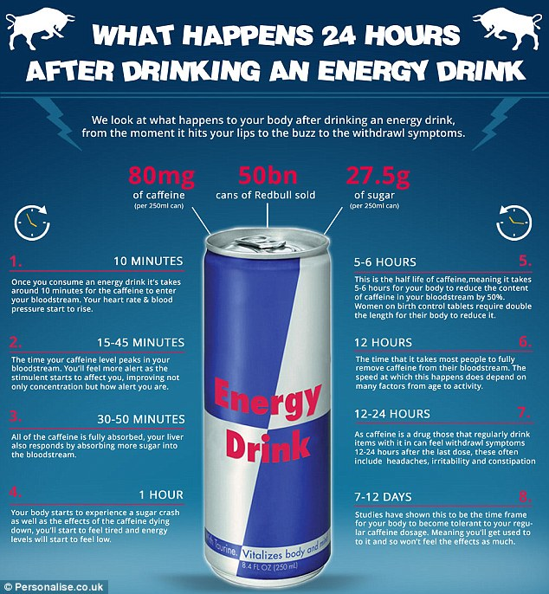Researchers from the Johns Hopkins School of Medicine, in a 2008 [review](https://www.ncbi.nlm.nih.gov/pmc/articles/PMC2735818/) published in the journal Drug and Alcohol Dependence, note that that lack of consistency is partly due to our long love affair with drinks in which caffeine is naturally occurring, including coffee and tea. In 1980, citing health concerns, the FDA proposed to eliminate caffeine from soft drinks, which are regulated as foods. The manufacturers, however, claimed the caffeine was a flavor enhancer. The FDA approved caffeine, but limited the maximum content of cola-type soft drinks to .02 percent, or roughly 71 milligrams per 12-ounce serving.

“If caffeine had not been accepted as a flavor enhancer, but had been regarded as a psychoactive ingredient,” write the Johns Hopkins researchers, “soft drinks might have been regulated by the FDA as drugs”—which are subject to additional regulations.

When energy drinks first appeared on the American market in the late 1990s and early 2000s, some manufacturers claimed the products were neither drugs nor conventional foods, but dietary supplements. Drugs with caffeine require warning labels, but dietary supplements don’t. “It is a striking inconsistency that, in the U.S. an [over-the-counter] stimulant medication containing 100 mg of caffeine per tablet (e.g. NoDoz) must include [a series of] warnings,” write the Johns Hopkins researchers, “whereas a 500 mg energy drink can be marketed with no such warnings and no information on caffeine dose amount in the product.”

In 2011, the American Academy of Pediatrics [concluded](https://pediatrics.aappublications.org/content/127/6/1182) that energy drinks “are not appropriate for children and adolescents, and should never be consumed.” Further, the group warned that adolescents might mistakenly use energy drinks, rather than sports drinks like Gatorade, for rehydration during physical activity. “Advertisements that target young people are contributing to the confusion,” wrote the authors.

Two years later, in 2013, questions about safety and marketing came to a head in the halls of Congress. Three Democratic senators launched an investigation into the marketing practices of energy-drink companies. They found that adolescents between the ages of 13 and 17 are frequent targets of energy-drink marketing, and stated in a written report that “this population is also at risk for the detrimental impacts of energy-drink consumption.”

Among those providing testimony at a committee hearing was Jennifer L. Harris, a researcher at the Rudd Center for Food Policy and Obesity, currently housed at the University of Connecticut. She and her team had conducted an earlier study of how sugary beverages are marketed to children. “What we learned about energy drinks stunned us,” she said at the [hearing](https://www.govinfo.gov/content/pkg/CHRG-113shrg88760/pdf/CHRG-113shrg88760.pdf).

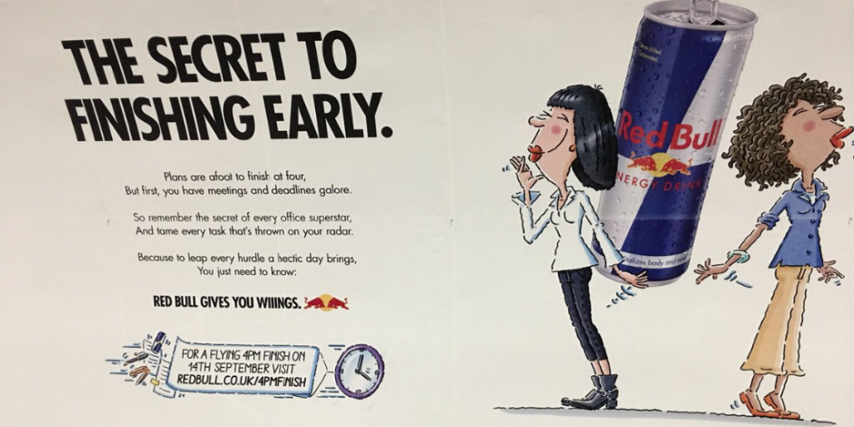Energy-drink companies had been pioneers in using social media to market their products, said Harris. At the time of her study, Red Bull and Monster Energy were the fifth and 12th most popular brands on Facebook—a platform that was, at the time, particularly popular among college students and adolescents. Further, said Harris, “energy-drink brands often promote teen athletes and musicians and sponsor local events, where they provide free samples, including to minors.” The marketing is effective, she noted. Sales of most other beverage categories were declining, but energy-drink sales had increased by 19 percent the previous year, reaching $8 billion in 2012.

[Red Bull](https://www.thedrum.com/topics/red-bull) has been cautioned by the Advertising Standards Association for this ad that the watchdog ruled makes unauthorized health claims. The complainant challenged whether the copy on the ad implied that Red Bull has a beneficial effect on health - in particular, focus and concentration.

The energy-beverage industry defended its products and marketing practices. In his congressional statement, Rodney Sacks, the CEO of Monster Beverage, noted that a 16-ounce can of Monster Energy contains 160 mg of caffeine. In contrast, the equivalent amount of Starbucks coffee contains 330 mg—more than twice as much. Further, Monster cans include a label recommending against consumption by children.

Further, Sacks and representatives from Rockstar and Red Bull North America denied that their companies advertise to young teenagers. Doing this, said Sacks, “would undermine the credibility of the brand image in the eyes of young adults,”—their target consumer demographic.

Not everyone buys this. A 2017 [study](https://www.ncbi.nlm.nih.gov/pubmed/29151382) tested whether young consumers perceived energy-drink advertising as being targeted at them. Researchers at the U of Waterloo assigned over 2,000 folks ages 12 to 24 to view one of four online ads for Red Bull. Among the youngest subjects—those ages 12 to 14—nearly 72 percent of participants who viewed an advertisement featuring the company’s sponsorship of the X Games, perceived the ad to be targeted to people their age.

The researchers compare energy-drink marketing practices with those of other companies. “While tobacco advertising was targeted only at adults,” they write, “it nevertheless achieved very high levels of reach and appeal among young people.”

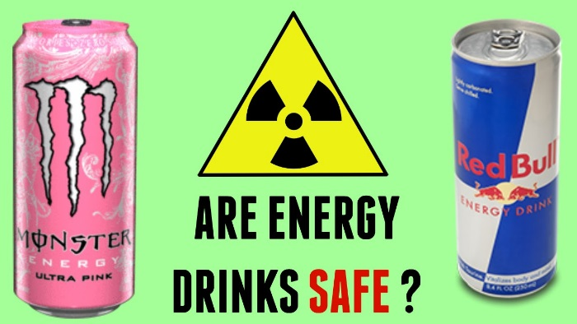Further, across all age groups, 71 percent of those who were shown a Red Bull ad with a sports theme—the X Games, for example, or an image of an airborne snowboarder with accompanying text reading “RED BULL GIVES YOU WIIINGS”—thought the ad they viewed promoted the use of energy drinks during sports.

When it comes to youth athletes, “our experts recommend both water and sports drinks as the best options for hydration,” writes Danielle Eurich. Athletes exercising less than an hour probably don’t even need sports drinks, she adds. “Water would be best.”

John Higgins, the sports cardiologist, ran a study in which healthy students drank a 24-ounce can of Monster Energy. 90 minutes later, the students’ arteries were measured to test their ability to bounce back—or dilate—after being compressed by a blood-pressure cuff. Dilation helps control blood flow, increasing circulation when necessary, including during exercise. In this study blood flow was “significantly and negatively affected,” says Higgins.

In 2017, Gary Watts, the coroner for South Carolina’s Richland County, released the autopsy results for Davis Cripe, the teen whose death spurred the state’s bill to ban sales of energy drinks to minors. The cause of death: a caffeine-induced cardiac event causing arrhythmia, which is when the heart beats too fast or too slow.

“Who’s to say that this hasn’t happened before?” says Watts, whose office has performed autopsies on other young adults who died of sudden death. “It probably has—it’s just that we’ve not been able to document the cause with someone on the scene at the time who says, ‘Okay, this is an arrhythmia.’”

Watts believes there are too many uncertainties about energy drinks to say that they are safe for adolescents. “I do think that the age is a concern that everybody needs to be really serious about.”

As for the Connecticut bill, it has not moved out of committee, but in May, the City Hill Middle School students and their teacher returned to the state capital to lobby lawmakers. They shared informational brochures created by the students, as well as informal results from a survey of students and parents, indicating widespread support for their bill among the latter. In the meantime, the students say, their siblings and peers continue to consume energy drinks—on soccer fields, in dugoutsh, and in front of video-game consoles.

“It’s so interesting,” a City Hill student, Emily Fine, said of energy-drink makers and their products, “how they still put them on the market.